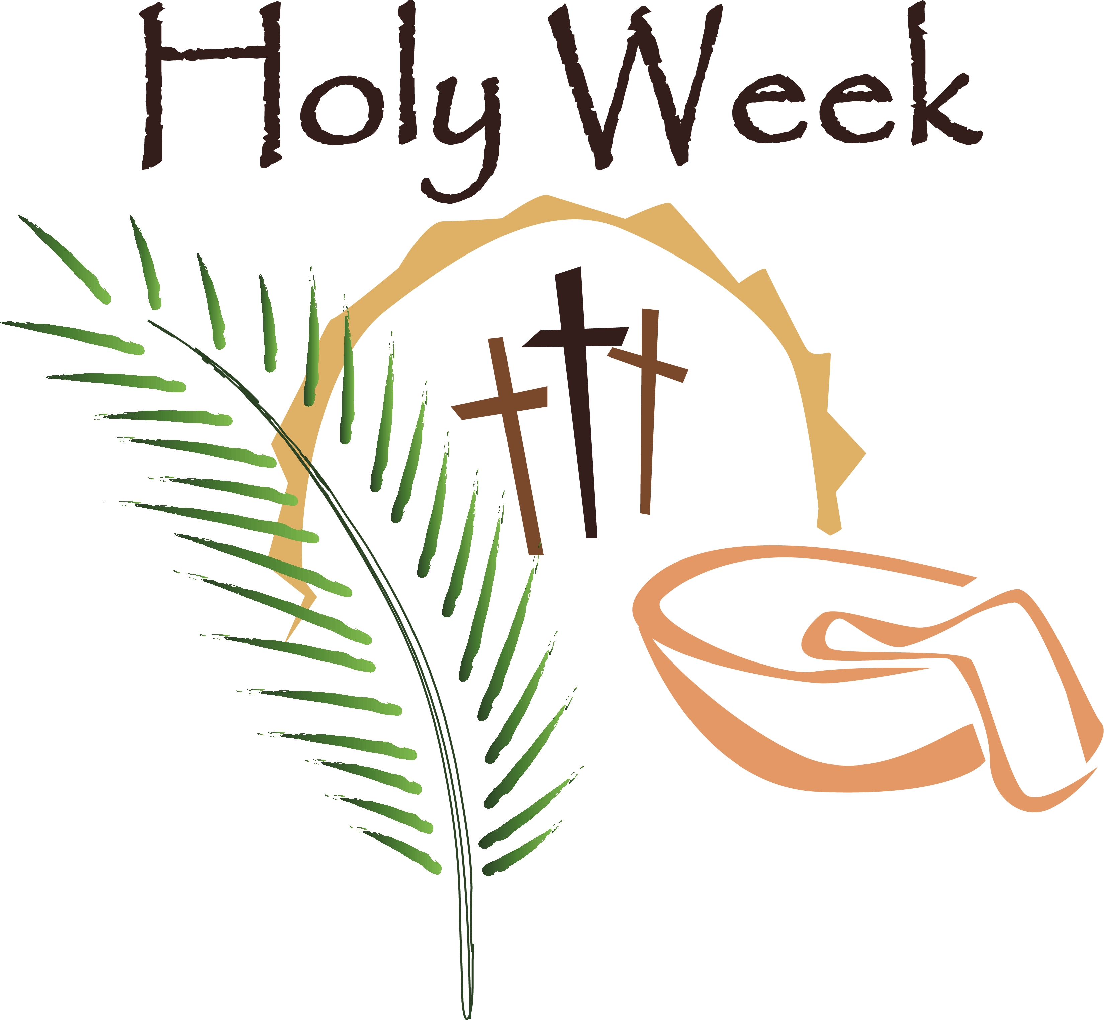
Resources for Faith at Home during Holy Week and Easter

Holy Week Family Resources

http://rowsofsharon.com/2013/03/13/good-friday-for-kids/ Suggestions on discussing the events of Good Friday with children http://pinterest.com/search/pins/?q=Holy+Week+with+kids Great at home ideas…we’re doing the “cave” in church school!

Ideas from the Methodist Church:
http://www.gbod.org/lead-your-church/holy-week/resource/observing-holy-week-in-the-home

http://www.gbod.org/lead-your-church/easter/resource/easter-devotional-for-families-bulletin-insert

http://www.gbod.org/lead-your-church/worship-with-children/resource/sharing-easter-with-your-children

Other idea Sources:

http://www.cresourcei.org/cyholyweek.html Background information about Holy Week

http://www.faith-at-home.com/tips/holy-week.html Background information and suggestions for Holy Week

http://www.cptryon.org/prayer/child/stations/index.html Stations of the Cross for older children
http://catholicicing.com/religious-easter-craft-for-kids-make/ Great idea for younger children to tell the story of Easter

http://prayerbookguide.wordpress.com/2013/03/18/palm-sunday-year-c/ For Adults

The Great 50 Days
of the Easter Season

From the Anglican Church:

http://www.faith-at-home.com/tips/easter50.html Resources for Easter season

http://www.domestic-church.com/CONTENT.DCC/20000101/FRIDGE/blessing_eggs.htm Blessing Eggs to make at home for use during the Easter Season

http://www.sundayschoollessons.com/easter.htm Nice explanation of The Easter Season

http://www.imom.com/recipes/dessert/resurrection-rolls/ Telling the story of the Resurrection while baking.

http://allrecipes.com/recipe/easter-story-cookies/ Another baking idea…resurrection cookies

http://www.christianbook.com/Christian/Books/gift_results?page=1451442&sp=107037&event=1023EAS|915270|107037 Christian Book Distributors has a great reasonable selection of books and items for children for use as a family or as a Easter basket gift.

