MCj01547220000[1]MCSO01651_0000[1]Palm Sunday for Children 2013

On Palm Sunday our children will join the procession beginning our worship and carry the palms into the Sanctuary. The palms will be blessed and we will distribute them prior to going to our classes. All children should gather with the choir by 9:45AM. If the weather permits we will meet in the park across the street but if the weather is not good we will meet in the hallway to the classrooms.

Class Focus on Palm Sunday

Primary and Intermediate Class: Will participate in “walking” The Way of the Cross”, a child appropriate stations of the cross. The classes will also make an “Empty Tomb” with figures, as a table symbol for use during Holy week.

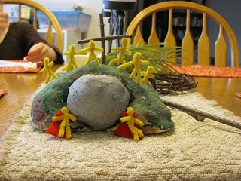

Table setting telling the story of Easter

Middle School Class: Members of this class will be reading The Passion during the 10:00AM worship. All other class members will attend worship

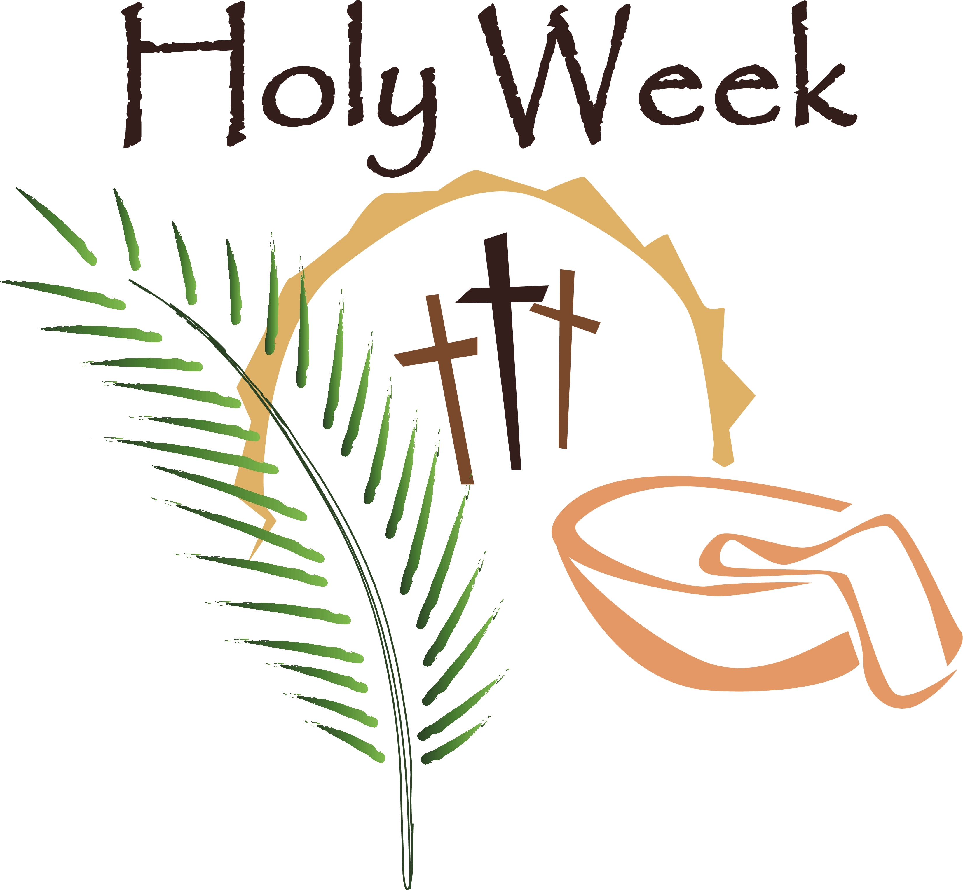Holy Week for Young Children

If the children in your life are young, Lent may be too long a waiting time. In that case, the week that begins with Palm Sunday may be just long enough for anticipating Easter. Use the clay mountain we will be making on Palm Sunday to depict what happened during the week. Resources will be sent home with the mountain to use during the week.

St. John’s Children’s Ministry Website  
[www.reddoorschildren.weebly.com](http://www.reddoorschildren.weebly.com)

Our children’s ministry website has a list of sites that you can use as a resource during Holy Week and the Easter Season (remember Easter is “TOO BIG” a mystery to be just one day….the season and celebration is 50 great days!

Our website also has our church school calendar and weekly updates and notes about Sunday worship and classes.