It’s Okay for Kids to be Bored During Church
July 9, 2015 by Melissa 92 Comments
Every Sunday my regular front row at church is filled with little girls (and Sawyer). I’m not really sure why these sweet little gals like sitting on the front row during worship, but I’m glad they do. They all bring their little notebooks and pens, and they draw during the sermon.
No one is playing on iPads or cell phones. No one is sleeping. No one is eating or drinking. There isn’t a single entertaining thing happening (except for my husband’s brilliant and lively sermons), but still they come to me week after week and sit there.
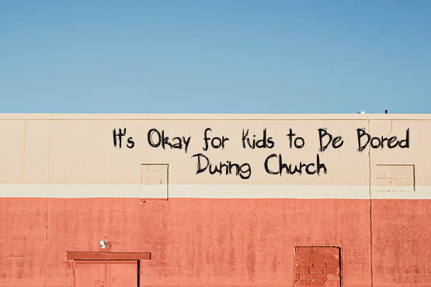
I know that many of us worry that our children will be bored during church. We fear that if they are bored they won’t want to go, and if they don’t want to go, then that doesn’t bode well for their future as good little Christians. For this reason we have created all kinds of awesome children’s church programs designed to keep them busy and interested. I think those things are great if they’re available to you.
But, I say it’s okay for kids to be bored at church.
Yes, you did just read that.
If you polled most church-going kids, I doubt that many would say that the sermon is their favorite part of the worship service. I don’t expect my kids to jump and down with excitement when it’s time to sit still and listen to talking for 40 minutes. But, I do expect them to sit still and be quiet. And, they do. My whole little pew of tiny church-goers do. They draw to pass the time, and then when the service is over, everyone goes home.
But, I’ve noticed something about my front row crew. When Chad tells a joke, they laugh. When he raises his voice, their pens stop moving. They look up. And, when I get my kids home and ask them what the sermon was about, they know exactly what was said, down to specific details. They may appear to be bored. They may appear to be concentrating on their drawings instead of hearing a sermon. But, the truth is that they are listening to every word that is being spoken.
I like and have often taught children’s church. At our church we don’t do children’s church during the summer, and I like that, too. Because kids also need the opportunity to learn how to be a part of the regular worship service. They need to be sitting with their parents, watching us as we worship. They need to begin building an understanding of how to be part of the service, how to function in a church environment that is not kids-only. They will benefit from having chances to worship as a family, and not exclusively in age-graded environments, even if it’s not their favorite type of church. Even if they would rather have a rock band and cool videos and games and jumping around.
If we give kids the opportunity, they will learn to appreciate the beauty of corporate worship that isn’t created exclusively with them in mind. They’ll begin to see what it is to be a church family.
God’s word is living and active. His Spirit is always at work, even in the lives of some sweet little girls (and one boy) on the front pew week in and week out. It’s okay for kids to be bored in church here and there. Let them color. Let them draw. And, if they wake up one morning and tell you they don’t want to go to church because it’s boring, don’t panic. Just keep being faithful. There is never any harm in exposing kids to biblical teaching, even if it’s not in their favorite format. We never know what kind of truth is being planted in their hearts while they sit quietly and draw.
Not everything at church has to be a big show or a major production. Let’s stop living in fear of our kids having a single moment of boredom. Take them to church. Let them sit. See how the truths they hear work their way into tiny hearts. And watch God work through the preaching of His word.

From: yourmomhasablog.com

