Join us as in celebration of God’s Love for us
and our love for each other
at
St. John’s Episcopal Church, Pine Meadow
Homecoming
Sunday, Sep 13th
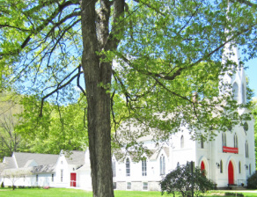
^{Godly Play 10:00 AM}
*
^{Worship 10:00AM}
*
^{Family Friendly}
^{Expanded Coffee Hour}
Church School Information
Registration form and Calendar for the fall - available on line Sept. 1st (copies will also be available Sept. 13th)

Calendar and information about our ministry is available on our website: http://reddoorschildren.weebly.com

More about St. John’s Episcopal Church at: www.reddoors.com

