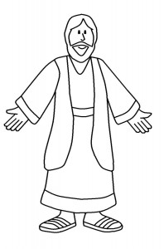
FLAT JESUS
As you travel and explore this summer,
be sure to take Jesus along with you!

Use your favorite colors and decorate the attached Jesus then carefully cut along the lines. As you visit new and exciting places this summer be sure to get a picture of you, your family, your friends, people you meet, and JESUS. Also, post copies of your travels with Jesus on our Facebook page or on the bulletin board in the entryway of the church.

Jesus said: “And remember, I am with you always, to the end of the age.”

St. John’s Episcopal Church
51 Church Street - Pine Meadow, CT
Be sure to post your Flat Jesus Pictures on FaceBook - St. John's Pine Meadow or via email to office @reddoors.com

