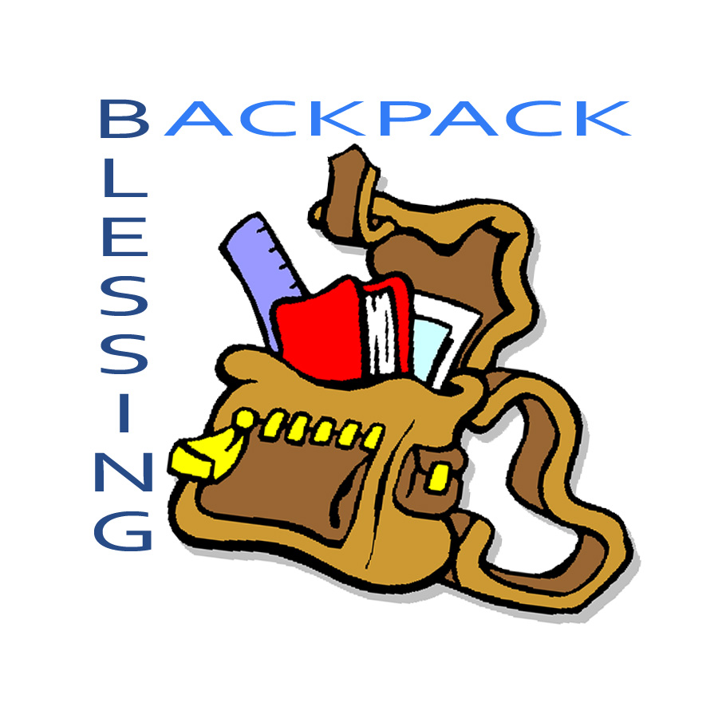
St. John’s Parish

Children and Youth

Sunday, Sept. 6th
10:00AM service
bring your school backpacks

Join us to have your backpack blessed and receive a blessing yourself as you begin your new school year.

Commissioning of Godly Play Leaders and Youth Leaders
and
Rededication of Parents and Congregation

During Homecoming Sunday
Sunday Sept. 13th
10:00AM Service

